HOSTED BY
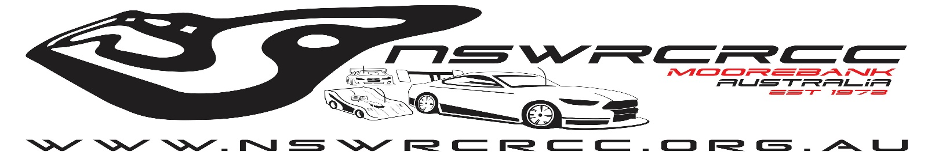
PRODLEY SPONSORED BY
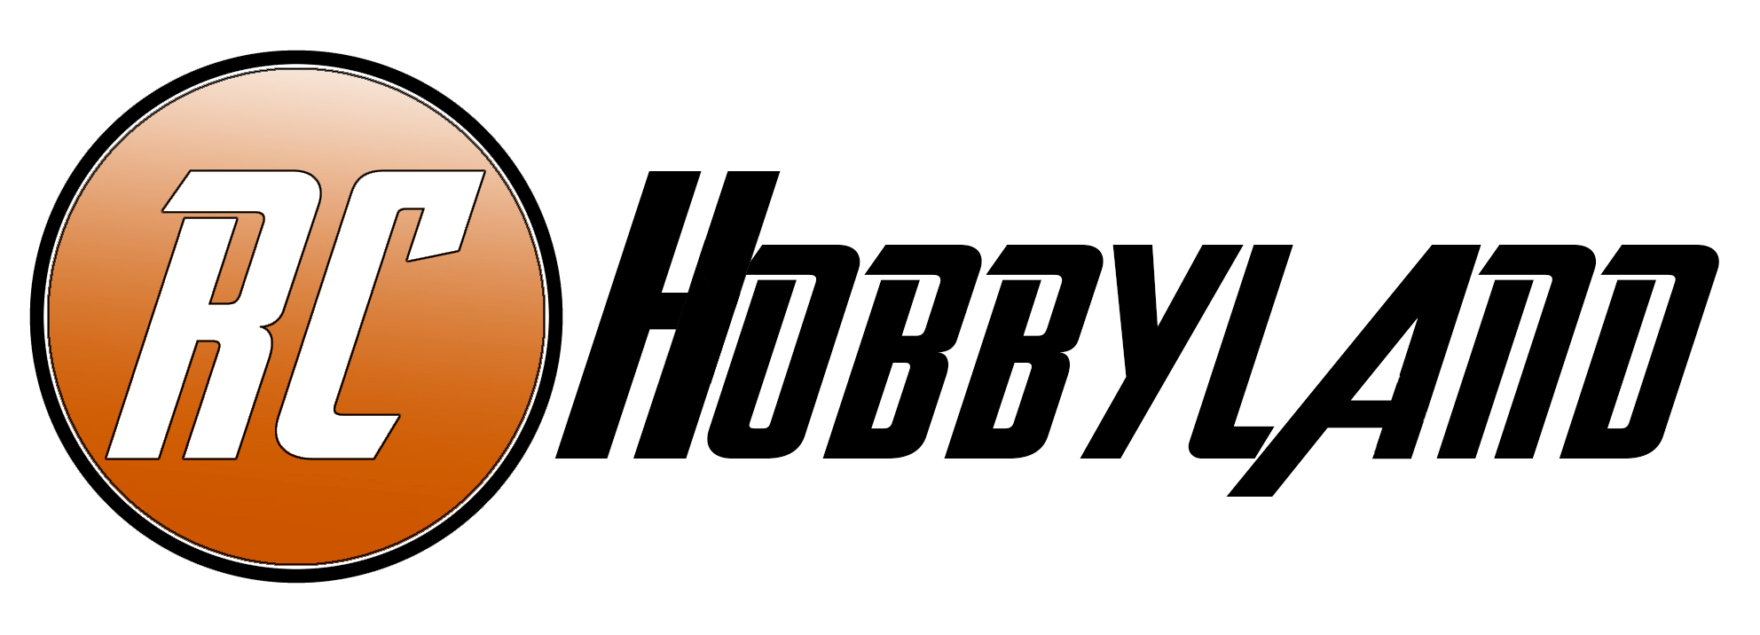
EVENT DETAIL
John Grant International Raceway, Moorebank are please to announce that we will be holding the 4th round of the 2021 XRS on road racing series Australia.
Highlighted below are all the details and links for the upcoming event.
Where
John Grant International Raceway
Helles Park, Helles Ave, Moorebank NSW 2170
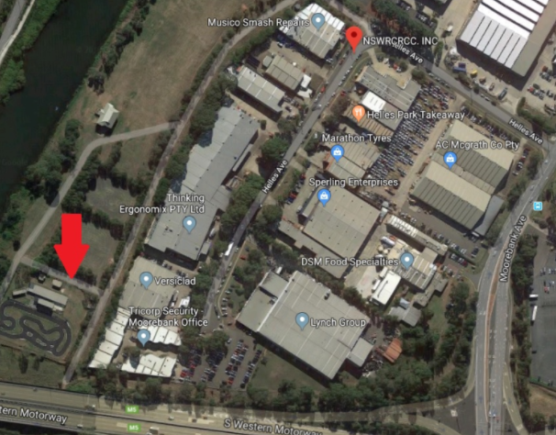

DATE
Saturday the 24th July 2021
9am to 10pm (Gates Open 7am)
Venue
The John Grant International Raceway is one of NSW’s Largest RC On-Road racing facility. The raceway is home to 1/5, 1/8, and 1/10 IC racing with the more recent addition of 1/8 and 1/10 EP. The facility houses a permanent tack and sheltered pit area with lighting and power and amenities for both male and female drivers.
XRS RACE DIVISIONS
EP Touring Car Modified (2 x Sets of Control Tyres)
EP Touring Car 13.5 (1 x Set of Control Tyre, Control Spec Motor)
EP Touring Car 17.5 (1x Set of Control Tyre, Control Spec Motor)
EP 1/8 GT Exhibition
RACE FORMATE
Each class will have three rounds of qualifying with the top qualification round from each driver to be the grid position for each of the three races race. Overall race results will be calculated based on the best two out of three race results.
Modified - 5min Qualifying and race
13.5 – 6min Qualifying and race
17.5 – 6min Qualifying and race
1/8 GT – 6 min Qualifying and race
CANTEEN
Food and drinks will be available on the day with a proposed BBQ lunch.
REGISTRATION
Event registration can be done by the link below on MYRCM. Please fill out all details via the link to speed up entry process on the day.
EVENT REQUIRMENTS
Control Tyre $45 – Sweep EXX-36R3PGX (Available from Campbelltown Hobbies and on practice and race days)
Control Motor $85 or $15 Daily Hire - Hobbywing XRS JUSTOCK G2 – 13.5 XY13.5G2.1 & Hobbywing XRS JUSTOCK – 17.5 XY15.5G2.1 (Available from RC Hobbyland and Practice/Event Day)
Special Note: No Traction compound can be utilised at this event. This will be monitored by the race official and scrutineering.

CONTACTS
XRS Race Series contact – Tony Smith 0474 538 034
Moorebank RC – Neal Hiland 0468 992 157

